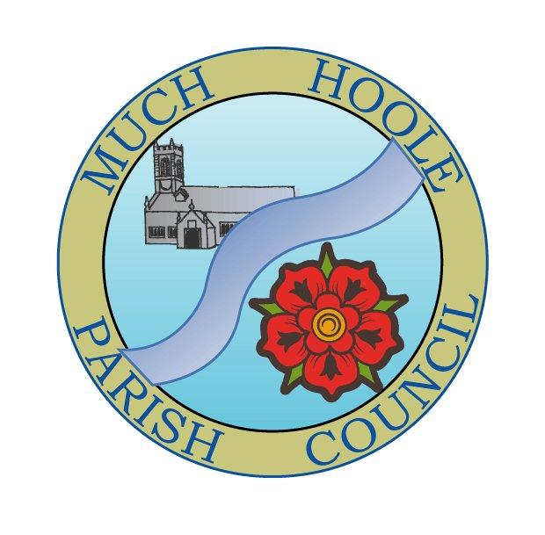 | MUCH HOOLE PARISH COUNCIL  NOTICE OF MEETING
You are hereby summoned to attend the Meeting of Much Hoole Parish Council to be held at 7.30pm on Monday 10th January 2022. The meeting will be held at the Venue (Hoole memorial village hall) Liverpool Road.
Russ Weaver, Clerk

AGENDA
1. | Apologies for Absence  To receive apologies for absence.
2. | Declaration of Interests and Dispensations  - To receive declarations of interest from Councillors on items on the agenda  - To receive written requests for dispensations for disclosable pecuniary interests (if any)  - To grant any requests for dispensation as appropriate
3. | Minutes of the Previous Meetings  To resolve to approve as a correct record the Minutes of the Council Meeting held on the 13th December 2021
4. | Public Time  To invite and listen to issues raised by members of the public.
5. | Reports from other meetings  The Council will receive reports from meetings where Councillors have attended as representatives
6. | Off Road Cycle Track  To consider any updates on the Cycle track and resolve any actions required.
7. | Finance and Audit  To resolve to authorise payment of the following:  - To resolve to pay the clerk salary in the sum of £240 (net) for December  - To resolve to pay HMRC in sum of £60 PAYE for December
8. | Community Projects update  To receive an update on any ongoing projects  To discuss suggested new projects:  - Cllr Richard Lea’s reports from the last meeting are circulated as a starting point for suggestions as to future projects  - Speed indicator devices  - Community Garden  - Remembrance Day arrangements for future years
9. | Support for the coastal path  Following the attendance of a member of the public at the December meeting, Councillors are invited to consider what support they wish to lend to the efforts to establish a new bridge as part of the coastal path
10. | Planning  Retrospective application for the retention of a refrigeration condensing unit  2A Smithy Lane, Much Hoole, Preston, Lancashire, PR4 4GN
11. | Village Hall development update  To receive and note a report on the progress of The Venue
12. | Review of Standing Orders  Councillors are asked to resolve to approve the existing standing orders.
13. | Review of Asset Register  Councillors are asked to resolve to approve the updated asset register
14. | Review of Financial Orders  Councillors are asked to resolve to approve the existing financial orders
15. | Review of Risk register  Councillors are asked to resolve approve the updated risk register
16. | Items for next agenda
17. | Date of Next Meeting  The Parish Council to agree the date of the next meeting as 7.30pm Monday 14th February 2022, to be held at ‘The Venue’, Liverpool Road, Much Hoole.

